ACIT 1630

Relational Database Design and SQL

Lab Exercise

Lesson 11

1. List the name, city, and state from the authors table, and the title, and type from the titles table where the state of the author is CA or TN. The name of the author should be formatted as the last name followed by a comma and space followed by the first name. There should be a row produced in the result set for each row in the authors table. Order the result set by the author’s last name. The query should produce the result set listed below. (Hint: LEFT OUTER JOIN statement)

name city state title type

------------------------ ------------------ ------- -------------------------------------------------------------- --------------------

Bennet, Abraham Berkeley CA The Busy Executive's Database Guide business

Carson, Cheryl Berkeley CA But Is It User Friendly? popular_comp

Dull, Ann Palo Alto CA Secrets of Silicon Valley popular_comp

.....

Stringer, Dirk Oakland CA NULL NULL

White, Johnson Menlo Park CA Prolonged Data Deprivation: Four Case Studies psychology

Yokomoto, Akiko Walnut Creek CA Sushi, Anyone? trad_cook

(20 row(s) affected)

Select concat(authors.au_lname, ', ', authors.au_fname) as 'name',

city, state, titles.title, titles.type

from authors

left outer join titleauthor on authors.au_id = titleauthor.au_id

left OUTER JOIN titles on titleauthor.title_id = titles.title_id

where (state in ('CA', 'TN'))

order by name

1. Using the INSERT command, insert a new row into the employee table. The employee has an id of TYS54321M, a first name of John, a last name of Smith, a job id of 12, a job level of 25, a pub id of 0877, and a hire date of March 1, 2012.

insert into employee values

(

    'TYS54321M', 'John', null,  'Smith', 12, 25, '0877', '2012-04-01'

)

1. Using the UNION command, calculate new prices for the books bases on the current price for each book in the titles table. If the price is greater than or equal to $15.00 and less than or equal to $20.00, add 10% to the price of the book, and if the price is greater than $20.00, add 5% to the price of the book. Order the result set by the title. The query should produce the result set listed below.

title price new_price

---------------------------------------------------------------------------------------- ----------- ---------------

But Is It User Friendly? 22.95 24.097500

Computer Phobic AND Non-Phobic Individuals: Behavior Variations 21.59 22.669500

Onions, Leeks, and Garlic: Cooking Secrets of the Mediterranean 20.95 21.997500

Prolonged Data Deprivation: Four Case Studies 19.99 21.989000

Secrets of Silicon Valley 20.00 22.000000

Silicon Valley Gastronomic Treats 19.99 21.989000

Straight Talk About Computers 19.99 21.989000

The Busy Executive's Database Guide 19.99 21.989000

(8 row(s) affected)

select title, price, (price + price*0.05) as 'price'

from titles

where price > 20

union

select title, price, (price + price*0.1) as 'new_price'

from titles

where price between 15 and 20

1. List the sum of quantity, and the sum of the year to date sales for each order by store id, store name, quantity, and year to date sales where the sum of the quantity is greater than 10. Display the store id, and quantity from the sales table, the store name from the stores table, and the year to date sales from the titles table. The query should produce the result set listed below.

stor_id stor_name quantity ytd_sales

--------- ---------------------------------------------------- ----------- -----------

7066 Barnum's 125 6140

7067 News & Brews 90 21611

7131 Doc-U-Mat: Quality Laundry and Books 130 32185

7896 Fricative Bookshop 60 24849

8042 Bookbeat 80 38997

(5 row(s) affected)

select stores.stor_id, stores.stor_name, sum(sales.qty),

sum(titles.ytd_sales)

from stores

inner join sales on stores.stor_id = sales.stor_id

INNER join titles on sales.title_id = titles.title_id

GROUP by stores.stor_id, stores.stor_name

having sum(qty) > 10

1. List all the authors in California who have written more than 1 book.

au_lname au_fname

------------------------------- -----------------

Green Marjorie

Locksley Charlene

MacFeather Stearns

O'Leary Michael

(4 row(s) affected)

select au_lname, au_fname

from authors

inner join titleauthor on authors.au_id = titleauthor.au_id

where authors.state = 'CA'

GROUP by au_lname, au_fname

HAVING count(1) > 1

1. List the average quantity, and the sum of the quantity from the sales table by store id, and the sum of the quantity of all the sales. Display the store id, order number, and quantity. The query should produce the result set listed below. (Hint: Use OVER)

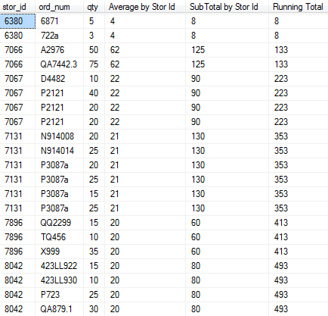

(21 row(s) affected)

select stor_id, ord_num, qty, avg(qty) over (PARTITION by stor_id) as 'Average by Stor id',sum(qty) over (PARTITION by stor_id), sum(qty) over (order by stor_id)

from sales